**Assignment**

1. **Write a java program to accept customer name,price of the product, quantity of product. if the salary of the customr is 10,00/- per month then what % of salary customer spent on purchase?**

Source code:

import java.io.*;

import java.util.*;

import java.util.Scanner.*;

class Purchase1

{

float total,spent;

String name;

float price,quantity,salary=1000;

public void details()

{

Scanner s=new Scanner(System.in);

System.out.println("Enter your Name:");

name=s.nextLine();

System.out.println("Enter the price:");

price=s.nextFloat();

System.out.println("Enter the quantity:");

quantity=s.nextFloat();

}

public void display()

{

total=(quantity*price);

spent=((total/salary)*100);

System.out.println("the customer is spent "+spent+"% of his/her salary");

}

}

public class Purchase

{

public static void main(String args[])

{

Purchase1 p=new Purchase1();

p.details();

p.display();

}

}

Output:-

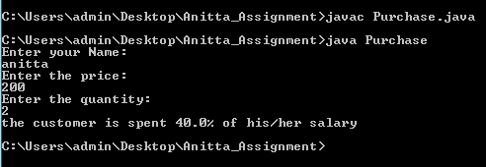

1. **Write a java program to accept customer name and rating for android one mobile phone. Display the average rating for the product.**

**Source Code:**

**Customer.java**

package test;

public class Customer {

private String name;

private int rating;

public String getname()

{

return name;

}

public void setname(String name) {

this.name = name;

}

public Customer()

{}

public int getrating()

{

return rating;

}

public void setrating(int rating)

{

this.rating = rating;

}

public Customer(String name, int rating)

{

this.name = name;

this.rating = rating;

}

}

**CustomerImpl.java**

package test;

import java.util.ArrayList;

import java.util.Scanner;

public class CustomerImpl {

static ArrayList<Customer> c1 = new ArrayList<>();

public static void main(String[] args) {

System.out.println("Enter number of customer ");

int n = new Scanner(System.in).nextInt();

for (int i = 0; i < n; i++)

{

Scanner scan = new Scanner(System.in);

System.out.println("Enter " + i + th " customer name");

String name = new Scanner(System.in).nextLine();

System.out.println("Enter " + name + " rating");

int rating = new Scanner(System.in).nextInt();

Customer cust = new Customer(name, rating);

c1.add(cust);

}

System.out.println("Average of rating is:- "+new CustomerImpl().getSum(list)/n);

}

public int getSum(ArrayList arr) {

int sum = 0;

for (Customer c : list) {

sum =sum+c.getrating();

}

return sum;

}

}

**Output**

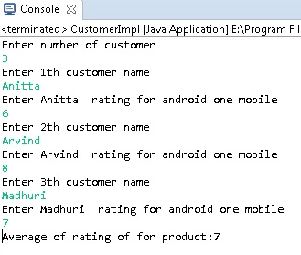

1. **Write a java program to accept student marks of 5 subject’s student name. calculate the percentage and display grade for the student**
2. **between 85 to 100% grade=A+**
3. **Between 75 to 84% grade=A**

**3. Between 64 to 75% grade=B**

**4. Between 50 to 65% grade=C**

**5.Below 50% grade=Fail.**

**Sourcecode:**

import java.io.*;

import java.util.*;

class Grade1

{

String name;

int m1,m2,m3,m4,m5,sum;

float t, grade;

public void accept()

{

Scanner s=new Scanner(System.in);

System.out.println("Enter Student's Name and Enter five subject’s marks here:" );

name=s.nextLine();

System.out.println("Enter marks " );

m1=s.nextInt();

System.out.println("Enter marks " );

m2=s.nextInt();

System.out.println("Enter marks " );

m3=s.nextInt();

System.out.println("Enter marks " );

m4=s.nextInt();

System.out.println("Enter marks " );

m5=s.nextInt();

}

public void grade()

{

sum=m1+m2+m3+m4+m5;

t=sum*100;

grade=t/500;

System.out.println("Average is "+grade);

if (grade<=100 && grade>=85)

{

System.out.println("A+ grade");

}

else if(grade<=84 && grade>=75)

{

System.out.println("A grade");

}

else if(grade<=74 && grade>=64)

{

System.out.println("B grade");

}

else if(grade<=65 && grade>=50)

{

System.out.println("C grade");

}

else

{

System.out.println(name+" Failed");

}

}

}

public class Grade

{

public static void main(String args[])

{

Grade1 g=new Grade1();

g.accept();

g.grade();

}

}

**Output:**

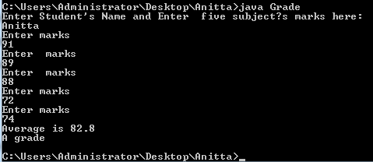

1. **Write a java program for addition of two matrices.**

Souce code

import java.util.Scanner;

import java.io.*;

public class AdddMatrix

{

public static void main(String args[])

{

int m,n,i,j;

Scanner in = new Scanner(System.in);

System.out.println("Enter the number of rows and columns of the matrix");

m = in.nextInt();

n = in.nextInt();

int first_matrix[][] = new int[m][n];

int second_matrix[][] = new int[m][n];

int sum[][] = new int[m][n];

System.out.println("Enter the elements of the first matrix");

for (i=0;i<m;i++)

for (j=0;j<n;j++)

first+matrix[i][j] = in.nextInt();

System.out.println("Enter the elements of the second matrix");

for (i=0;i<m;i++)

for (j=0;j<n;j++)

second_matrix[i][j] = in.nextInt();

for (i=0;i<m;i++)

for (j=0;j<n;j++)

sum[i][j] = first_matix[i][j] + second_matrix[i][j];

System.out.println("Sum of entered matrices is:");

for (i=0;i<m;i++)

{

for (j=0;j<n;j++)

System.out.print(sum[i][j]+" ");

System.out.println();

}

}

}

Output:

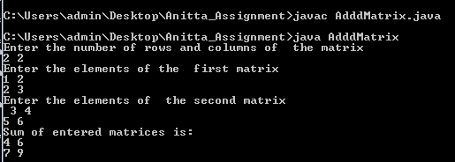

1. **write a java program to print matrix transpose**

**Sourcecode:**

import java.io.*;

import java.util.Scanner;

class TransposeMatrix

{

public static void main(String args[])

{

int m, n, i, j;

Scanner in = new Scanner(System.in);

System.out.println("Enter the number of rows and columns of the matrix");

m = in.nextInt();

n = in.nextInt();

int matrixM[][] = new int[m][n];

System.out.println("Enter the elements of matrix");

for (i=0;i<m;i++)

for (j=0;j<n;j++ )

matrixM[i][j] = in.nextInt();

int transpose_matix[][] = new int[n][m];

for (i=0;i< m;i++)

{

for (j=0;j<n;j++ )

transpose_matrix[j][i] = matrixM[i][j];

}

System.out.println("Transpose of the Matrix is:");

for ( i=0;i<n;i++ )

{

for (j=0;j<m;j++ )

System.out.print(transpose[i][j]+" ");

System.out.print("\n");

}

}

}

**Output:**

